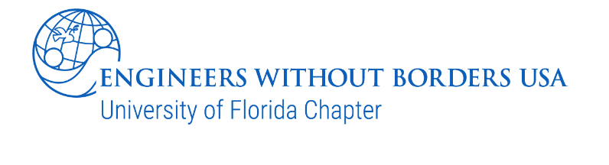

UF EWB TEAM APPLICATION 2024

WHO WE ARE
Thank you for your interest in joining UF Engineers Without Borders! We are a team dedicated to bringing education, outreach, human-centered design, and humanitarian aid to communities in Nepal and Peru. We are looking for individuals with shared passion in these areas, and we are open to all majors, skill levels, and interests. There are many different subteams working towards this goal, which include Fundraising, Design, Communications, and Public Relations. Whatever your interest, EWB has a place for you. Please email us with any questions and feel free to contact any of the team members listed below.

Submit completed applications to ewb.ufl.involvement@gmail.com no later than 11:59 PM on Friday, September 20.

CONTACT INFORMATION
President: ewb.ufl@gmail.com
Member Engagement: ewb.ufl.involvement@gmail.com
Nepal Project: https://www.ewbuflnepal.com/
Peru Project: https://www.ufewbperu.com/
Instagram: @ewb.uf / @ewbufnepal / @uf.ewb.peru

WHO SHOULD APPLY?

Everyone! Our mission is to improve water and sanitation systems for our partner communities in Nepal and Peru by implementing innovative and sustainable solutions. Meeting schedules include a mandatory biweekly General Body Meeting for all members with additional weekly subteam meetings.

Our team requires a variety of experience to be successful. The main focuses are:
- Design: Technical assessment, implementation, and project planning. Although a plus, it is not mandatory that you already have technical skills. You should simply have an interest in human-centered design and be willing to learn about constructing water projects.
- Communications: In constant conversation with our communities and school partners in either Nepal or Peru (Bonus if you are fluent in Nepali or Spanish). As part of the communications team, you will be working closely with our design teams. Fundraising team and PR team. This can look like helping out with marketing on occasion or drafting a project budget in local currencies or even increasing cultural literacy within the team and larger community.
- Fundraising: In charge of raising money through events, grants, merchandise, newsletters and rotary presentations. This subteam is essential to our success as a team and is perfect for anyone not interested in the actual design and construction process, but rather the business and networking behind it.
- Public Relations: Tasked with all things internal to the team. This includes planning socials to improve member engagement, social outreach, volunteering, as well as social media (Instagram, LinkedIn, etc.). PR works closely with the other subteams due to the overlap in marketing and planning events. PR is perfect for those interested in the aspects of running an engaging club, in addition to marketing and advertising.
  - Web Design: Building and designing our new team website from scratch, as well as updating and maintaining the website. Coding and web development experience preferred.

APPLICATION PROCESS

Application Package Components
Please submit the following application materials:
- Application
- Resume (required)

Application Process:
- Please submit ONLY the Application Package materials and your resume as two separate PDF files.
- Submit completed applications to ewb.ufl.involvement@gmail.com no later than 11:59 PM on Friday, September 20th. Please use the subject line “2024 Application”.
- Confirmation emails will be sent out within one day after your application is received.
  - If confirmation email is not received, please re-send the application.
- The applicant will be notified if they received an interview three to five days after applications have closed.
- Select applicants will be invited to an in-person interview that will be held on Saturday, September 28th. Make-up day is a zoom interview on Sunday, September 29th.
- If you are unable to interview on those dates, please notify us as soon as possible by emailing us at ewb.ufl.involvement@gmail.com.

When you have completed the application, send an email to ewb.ufl.involvement@gmail.com with your application. After it is submitted, if we are interested in having you on the team, we will contact you about setting up a one-on-one interview.

PART I - GENERAL INFORMATION
- Name:
- Major:
- Year:
- Graduation Date:
- UF Email:
- Phone:
- Where will you be during the Fall 2024 semester? Gainesville Other
- Rank your interest level in each subteam from 1-4 (1 being top choice):

  - Design (Circle one if you have a preference - Peru OR Nepal)
  - Communication (Circle one if you have a preference - Peru OR Nepal)
  - Fundraising
  - Public Relations

PART II - SHORT ANSWER QUESTIONS (Please keep answers between 100-300 words.)
- Working on an international project can be demanding, especially as deadlines for design submissions and grant applications approach. Mention the activities you currently participate in, and approximate the amount of time you would be willing to invest in our team, given an average weekly contribution is approximately 3-5 hours.
Activities and Involvement:
Hours per week you are willing to dedicate to EWB:
- Why do you want to join the EWB Team? What aspects interest you most about being part of our team?
- What assets and skills would you bring to our team, and specifically to your desired subteam? Have you had experience working with people of different cultures or beliefs from yours? Please provide examples and relevant experience.

- Answer ONE of the following questions:
  - How will your personal background and experience contribute to the overall team culture?
  - Describe a time you worked with someone from a different culture or set of beliefs? Discuss what you learned and how what you learned will contribute to the team overall.
- Is there anything else you would like to mention that hasn’t already been reflected in your application? This could include anything such as relevant coursework, research, etc. *Optional

